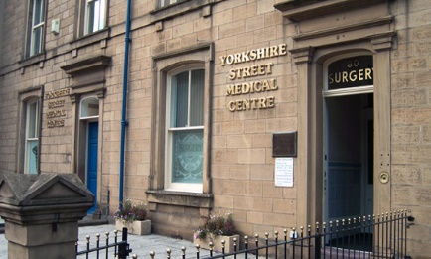
Yorkshire Street Medical Centre

Feedback and Complaints Procedure

Patient Leaflet

At Yorkshire Street Medical Centre we provide high quality, safe services which meet the needs of our patients. We treat people with care, respect and dignity and communicate using language which is easy to understand.

We want to hear from you

All patients using our services are given the opportunity to give us feedback after their appointment. All comments are reviewed, and used to improve the care we provide. Feedback from your family and friends is also welcome. We are always pleased to hear when things have gone well and we make sure this feedback is passed on to our staff.

How to complain

We also want to hear if things have not gone well. If you are not happy about any aspect of our service please speak to one of our front line staff who will do all they can to put things right. If staff are not able to deal with your concern at the time, or if you wish to take it further, they will offer you the opportunity to speak to our Practice Manager.

Alternatively you can contact the Practice as soon as possible by letter, email, phone, or in person:

Yorkshire Street Medical Centre, 80 Yorkshire Street, Burnley, Lancashire BB11 3BT
Phone: 01282 501413
Email: scripts@nhs.net

All complaints will be acknowledged within 3 working days of receipt.

If you are complaining on behalf of someone else, they will need to complete a consent form to say they are happy for us to discuss their care with you. We will send this form to them for completion.

Monitoring complaints

All the feedback we receive is recorded. We also keep a register of complaints received, including information on the investigation and action taken as a result.
Complaints received by the practice will be reviewed to ensure that learning points are shared with the whole practice team.

What happens if I am unhappy with the outcome?

You can contact the Patient Advice Liaison Service (PALS). PALS is intended to be a resource and support facility for the patients and health care providers. They aim to have a swift resolution to problems and be neutral in dealing with cases. You can find your nearest PALS office on the NHS Choices. Or you can refer your complaint directly to:

The Parliamentary and Health Service Ombudsman
Millbank Tower
30 Millbank
London
SW1P 4QP
Tel: 0345 0154033
Website: www.ombudsman.org.uk
http://www.ombudsman.org.uk/make-a-complaint

Lancashire and South Cumbria Integrated Care Board
NHS Lancashire and South Cumbria ICB,
Jubilee House
Lancashire Business Park
Leyland
PR26 6TR
Mlcsu.lscpatientexperience@nhs.net

Confidentiality
All complaints must be treated in the strictest confidence
The practice must keep a record of all complaints and copies of all correspondence relating to complaints, but such records must be kept separate from patients’ medical records.

